Maintain Position Type Knowledge Article

Contents
Document Version Control 1
Approved process for raising 2
Consultation & Approval 2
Change Management 2
How to 3
Testing 5
Communications 5
Downstream Systems & Processes 5
Affected Reports 5
Additional Background Information 5

Document Version Control
Change History/Review Details
Date | Version | Review by | Summary of Change
17/02/17 | 0.1 | S Burford | Initial Draft
04/07/23 | 0.2 | Michael O’Sullivan | Updated to reflect move from the Back Office to the Portal

Approved process for raising
Does the change need to be raised through a particular route or by a particular person/team? Are there any actions which need to be taken or considered prior to processing in the HRIS Support Centre?
The Standard process for creating or amending a Position Type is for the request to be made via an Incident that will be assigned to the Functional Analysis team within OSM the Oxford Service Management tool. It should be clear from the incident if the request is for a new Position Type or an amendment to an existing.

Position Types are linked heavily with the Staff Request process. Any proposed new or changes to existing Position Types should be raised by the Reward Team following the above route.

Consultation & Approval
Who is the owner of this information? Who needs to be consulted about this change before you begin work on it? Does anyone need to approve this change before it is implemented?
The Reward Team are primarily responsible to agree any new or changes to Position Types.

The Functional Analysis team within HR Systems are responsible for maintaining the data within the PeopleXD system.

Change Management
What type of change is this? When should approval be sought and from whom (internal to team or change manager)? Who would normally be responsible for implementing?
New or changes to existing Position Types should be raised as a Minor Change within OSM the Oxford Service Management tool. All requests will need to be tested in a UAT environment before entering into the live production environment.

How to
Technically how to process the change in the system
Adding a new ….
Navigate to: PeopleXD > People Management > Data Centre > Reference Data > Position Types

Each reference data item is listed in order of Position Types Code. This is an alpha code which itemises each Position Type. Once set these cannot be changed but the “Description” of each can be updated. It is not possible to delete a Position Types Code if being used on the Recruitment Table, which occurs if the code has been used on a Staff Request or Vacancy.

If possible, you should look to recycle existing codes as there is no option to set them as active or inactive. If new codes do need to be created, simply click on the Add button

The “Position Types code” can be any code not yet used. The “Description” column has a limit of 40 characters including spaces and will be the list which is shown on the Staff Request to end users so must be logical and descriptive. The “Description” will be provided by the Reward Team:

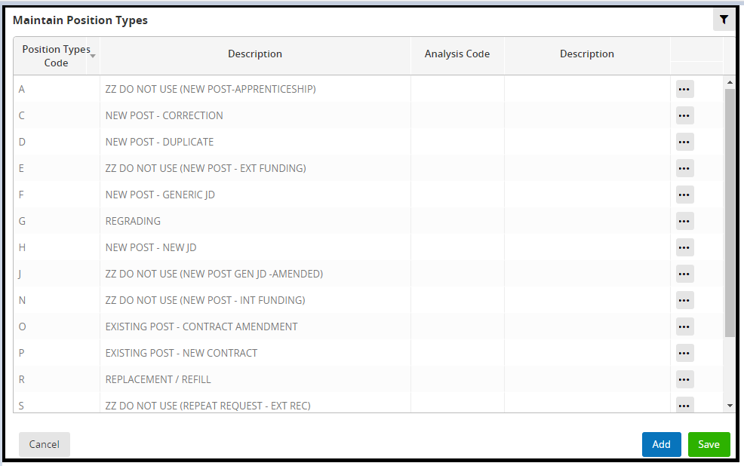

Changing a ….
Navigate to: PeopleXD > People Management > Data Centre > Reference Data > Position Types

Each reference data item is listed in order by the Position Types Code. This is an alpha code which itemises each Position Type. Once set these cannot be changed but the “Description” of each can be updated. It is not possible to delete a Position Types Code if being used on the Recruitment Table.

If possible, you should look to recycle existing codes as there is no option to set them as active or inactive. If new codes do need to be created, simply click on the Add button

The “Position Types code” can be any code not yet used. The “Description” column has a limit of 40 characters including spaces and will be the list which is shown on the Staff Request to end users so must be logical and descriptive. The “Description” will be provided by the Reward Team:

Removing a ….
Navigate to: PeopleXD > People Management > Data Centre > Reference Data > Position Types

You cannot delete or mark these codes as inactivate once set up and selected within a Staff Request or Vacancy as this creates a link within the Recruitment Table.

If the code has not been utilised and there are no recruitment Table links then this can be deleted. Click on the Ellipses button and select Delete.

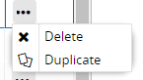

Where a code is no longer required but has been utilised and Recruitment Table links exist, you must change the description to include “ZZ DO NOT USE(^{[original description]})” as a workaround.

You may find you need to shorten the original description to now fit within the 40 character limit.

You can see how this appears in the Staff Request list below:

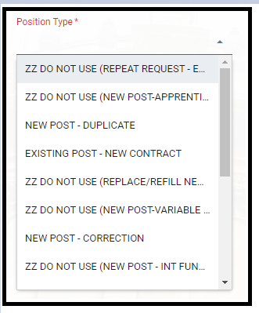

Standard Icons & Terminology
Standard Button Names  Enter Query button:  Previous Record button:   Previous Section button:   Save button:   Insert Record button:  | Execute Query button: 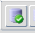  Next Record button:   Next Section button:  LOV button:   Delete Record button:  | Cancel Query button: 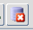  Red Door button:   Duplicate Record button:
Navigation Paths

Show the final navigation path option in bold+italics, for example;
Core|Personnel > Reference > Reference A – C > Accident Codes
Core|Pay > Reference > Pay Groups

Any further navigation beyond the navigation path can be added after an ellipsis (…), for example;
Event Management > Event Configuration … HR Events > Change of Address

Testing
Who would normally be responsible for testing? Are there standard items to test?
Functional testing can be carried out by using the new/amended codes on a staff request and on the Vacancy Profile screen.

User Acceptance Testing should also always be carried out to ensure that any changes made to these codes fit the Reward Team’s processes.

Communications
Who needs to be informed (but not consulted) about this change? Detail when they should be informed (before or after the change).
The Reward Team should manage the bulk of the communications as any amendments to this list will indicate a change of process for the Staff Request process.

Downstream Systems & Processes
Details of any processes which are affected or need to be carried out following, or as part of, the change. Please detail any triggers, actions required and when the actions should be carried out.
The Staff Request and Decision Matrix will need to be reviewed and likely updated as part of any changes in this area.

QRGs may also need to be updated.

Affected Reports
Are there any standard reports which may need to be updated following this change?
TBC – not aware of any yet.

Additional Background Information
Any other relevant information, links to supporting documentation etc.

